**SOFTWARE PROJECT 1**

**Ahmed, Fahim [14-27678-3]**

**Sultana, Jakia [14-27871-3]**

**Rana, MD. Rasel [14-28185-3]**

**UNDER THE SUPERVISION OF**

**MD. AL IMRAN,   
Assistant Professor**  
Faculty of Science and Information Technology



American International University-Bangladesh (AIUB)

**Summer 2016-2017**

Declaration

We declare that the submitted project is our original work and has not been submitted in any form for another degree or diploma at any university or other institute of tertiary education. Information derived from the published and unpublished work of others has been acknowledged in the text and a list of references is given.

We declare that this project does not contain any content that discloses the secret of any organization or related parties. American International University – Bangladesh (AIUB) will not be held liable for any such activities, as for the project is presented as our original work.

………………………… …………… ……………………………………..

Ahmed, Fahim Sultana, Jakia

ID: 14-27678-3 ID: 14-27871-3

Dept.: SE Dept.: SE

………………………………………

Rana, MD. Rasel

ID: 14-28185-3

Dept.: CSSE

Approval

This software project “**Blood Bank Management System**” has been submitted to the following respected members of the board of examiners of the Department of Computer Science in partial fulfillment of the requirements for the degree of Bachelor of Science in Computer Science and Software Engineering and Software Engineering has been accepted as satisfactory.

|  |  |
| --- | --- |
| _______________________________  **MD. Al Imran**  Asst. Professor & Supervisor  Department of Computer Science  American International University-Bangladesh | _______________________________  **MD. Masuduzzaman**  Lecturer & Co-Supervisor  Department of Computer Science  American International University-Bangladesh |
|  |  |
| _______________________________  **Dr. Dip Nandi**  Sr. Asst. Professor & Head  Department of Computer Science  American International University-Bangladesh | _______________________________  **Professor Dr. Tafazzal Hossain**  Dean  Faculty of Science & Information Technology  American International University-Bangladesh |
|  |  |
| _______________________________  **Dr. Carmen Z. Lamagna**  Vice Chancellor  American International University-Bangladesh | |

Acknowledgement

First of all we would like to be grateful to the almighty Allah who gives us the effort to work on this project. Thanks to our respectable parents for their outstanding support at every point in our life. We want to thank our honorable supervisor **MD. AL Imran**. Their excellent supervision, constant support makes this project possible.

**Index**

|  |  |  |  |  |
| --- | --- | --- | --- | --- |
| **Chapter No.** |  | | **Chapter Title** | **Page** |
| 1 | 1.1 | **Introduction**  Introduction…………………………………………….. | | **7-7**  7 |
| 2 | 2.1  2.2  2.3  2.4  2.5  2.6  2.7  2.8  2.9  2.10 | **Statement Of Work**  Purpose/Object………………………………………….  Scope……………………………………………………  Proposed System………………………………………...  System Features…………………………………………  Environment…………………………………………….  Assumptions……………………………………………..  Constraints………………………………………………  Resources………………………………………………...  Project Time……………………………………………...  Assessing Overall Project Risk…………………………. | | **8-11**  8  8  8  8  9  9  9  10  10  11 |
| 3 | 3.1  3.2  3.3  3.4  3.5  3.6  3.7 | **Software Requirement Specification**  Objective and Scope……………………………………  Overall of the Present System…………………………...  Data Flow Diagram……………………………………...  Overview of the Proposed System………………………  Benefits of Proposed System………………………..  System Features………………………………………….  Conclusions…………………………………………….... | | **12-13**  12  12  12  12  12  13  13 |
| 4 | 4.1  4.2  4.3  4.4 | **Diagram And Database Table**  Use Case Diagram………………………………………  Entity Relationship Diagram……………………………  Data Dictionary ………………………………………... Schema Diagram ………………………………………. | | **14-20**  14  18  19  20 |
| 5 | 5.1  5.2  5.3  5.4  5.5  5.6 | **Software Project Management Plan**  Overview………………………………………………..  Project Organization……………………………………  Managerial Process Plan………………………………..  Control Plan……………………………………………..  Closeout Plan…………………………………………….  Other Plan………………………………………………. | | **21-25**  21  21  22  22  23  23 |
| 6 | 6.1  6.2  6.3  6.4  6.5 | **User Interface**  Login Panel……………………………………………  Donor Registration Panel……………………………..  Admin Panel…………………………………………..  Pathologist Panel……………………………………...  Nurse Panel…………………………………………… | | **26-28**  28  28  29  30  31 |
| 7 | 7.1  7.2 | **Conclusion**  Future Aspect……………………………………………  Conclusion……………………………………………… | | **29**  29  29 |

Chapter 1: Introduction

* 1. **Introduction:**

This management system is mainly uses for helping the organization to manage their donor, organizational data and personnel data. So this document consists of detail explanation about the system and its features along with logical model, user scenario and diagrams. It contains the whole SRS structure along with management plan and UI structure. The document mainly focuses on providing sufficient design information to the blood bank authorities. And also it will satisfy the functional, design, performance requirements of the system in briefly.

Chapter 2: Statement of Work

**2.1 Purpose/Objectives:**The main purpose is to help the organization for maintaining donor data and access the data as per need. The software can also track donor details and staff details which is accessible by administrator and staff.

**2.2 Scope:**   
The management system will consist of different user group. The Admin, Nurse and Pathologist. These three user group can access the software from their system. Nurses have the most functionality though they have no administrative power. They will register a donor by their name, address, phone number, email address, gender, eye color, blood group and hair color. The system will store those information to the database. Donors’ blood test report will check by the pathologist and he will approve / deny the request and update the database table data. Every donor will have a unique id number. The system will store every pathologist / nurse details into the database and it can be show only by administration. An admin can delete, update, and view the whole database.

**2.3 Proposed System:**

The purpose of implement this system to reduce the time of searching registered donor and keep track of the donor details for future references. The system can save a life by provide blood for the patient who is in medical emergency.

**2.4 System Features:**

This system is used for managing whole a blood bank system.  
There are 3 kinds of user module are there.   
1. Admin  
2. Nurse  
3. Pathologist  
  
**Admin:** Admin module focuses on managing the overall system. Admin can manage doctors and medical staff’s registration confirmation. They can calculate the total amount of blood received and sold out.   
There are also several option for them.

1. View and Change their profile details.
2. Maintain Donor details
3. Maintain Doctors and medical staffs.
4. Update and delete doctors and medical staffs
5. Logout

**Nurse:** Nurse Module focuses on managing customers and donors details. They are entitled for registering new donor and generate invoice for a customer or token for donor who are already registered.

1. Manage the registered donor.
2. Generate invoice for customer.
3. View and change their personal profile.
4. Logout.

**Pathologist:** Pathologist can check the medical report and based on the medical test result he will approve or deny the donor. If he finds any fault in medical report he will deny the request. If there is clean medical test report then he will approve the request. The database table will show the approval status of a particular donor.

1. Manage personal profile and details.
2. Update a donor’s test report.
3. Logout.
   1. **Environment:**

**2.5.1 Organizations Involved**

Project Client: MD. Masuduzzaman Prince & MD. AL Imran

Developer: Dot Development Limited

User: Authority and Users.

* + 1. **Processing:**

1. This desktop application will have a user friendly graphical user interface.
2. That means it’s a desktop application which is desktop independent.
3. Three working module admin, medical staffs and doctors.
4. Authenticated & secure login system for all user group.
5. The software will store all the data of users.

**2.5.3 Security**

1. Users authentication is required to access the application

2. All the stored data is secured.

**2.6 Assumptions**

The software is built through Microsoft Visual Studio 2015 and the programming language is C#. We also use some oracle query to execute query in the server and fetch data from server. For database purpose we used MySQL server. So our project is not affected by anything because we gather tools license from MSDN and it is totally legal.

**2.7 Constraints**

1. We faced some problem when we are trying to add email notification system.
2. Sometimes the database query cannot execute properly. So we run the query again.
3. When the application run parallel the application may work slowly so we run the application single.

**2.8 Resources**

All the resource used is provided below.

**2.8.1 Hardware:**

1. Processor: Intel core i5 6500
2. Memory: GSkill 8GB DDR-4 2400 Bus
3. Hard Drive: Western Digital 1 TB
4. SSD : 120 GB PNY Phantom
5. Graphics card: Gigabyte Wind Force R7 370 4GB DDR5
6. Monitor: LG 21” IPS Display
7. Keyboard: Standard
8. Mouse: Standard

**2.8.2 Software**

* 1. Microsoft Visual Studio 2015
  2. MySQL server
  3. Github

**2.8.3 Operating Environment**

This is the first time we made a whole project. We used Microsoft Visual C# to make the software. Especially the windows based system will support the system. In future we will make this application for Linux based system and we will add more functionality.

**2.9 Project time**

**2.9.1 Project Period**

* Time of project completion is 4 months

**2.10 Assessing overall project risk**

**1. Have software engineer team formally committed to support the project?**

**Answer:** Yes. All the members are formally committed to support the project**.**

**2. Are requirements fully understood by the software engineering team and their customers?**

**Answer:** Yes. As the software engineering team or the developers has the sound knowledge about the requirements so it is easily understandable by the team. The requirements details are well organized also informative, so it is under stable by the customers.

**3. Are end-users enthusiastically committed to the project and the system/product to be built?**

**Answer:** Yes. Because the end-users are expecting that, they will be able to find all kind of information.

**4. Have user been involved fully in the definition of requirements?**

**Answer:** Yes. The user has been fully involved in the definition of requirements. They are aware of the application requirements.

**5. Is project scope stable?**

**Answer:** Yes. Project scope is stable because the minimum and mandatory scope is almost covered by the software engineering team. If any further scope will arise then just adding it with the old ones.

**6. Does the software engineering team have the right mix of skills?**

**Answer:** Yes. The software engineering team has the right mix of skills. The team members have the capability of doing their work in a team, ability to work in pressure and also have sound knowledge according to the software implementation.

**7. Are project requirements stable?**

**Answer:** Yes. Currently all possible requirements are being listed, and seem that if anything would be added later to the list will not make the project unstable. All requirements for this project are easily available that will enthusiast the end-user to use it.

**8. Does the project team have experience with the technology to be implemented?**

**Answer:** Yes. The project team has experience with the technology to be implemented because they have the sound knowledge about the technologies and the technologies are also implemented by them before.

Chapter-3: Software Requirement Specification

**3.1 Objectives and scope**

The objectives and scope of this project is to reduce the complexity of blood bank. The blood bank can store all the donors’ details and track the blood donation record also the customer’s record.

1. User friendly UI to interact with the system.

2. Make a database to store all the information

3. Individual module for admin and user.

Admin has the highest authority over the entire system. Admin responsibility is to update or modify existing system, ensure data security. The nurses can search the donor. The pathologist can approve / deny a donor.

**3.2 Overview of the present system**

Currently there is a lot of blood bank management system available in the market. But our product will give the user more user friendly experience.

**3.3 Data Flow Diagram of the Present System**

Not required.

**3.4 Overview of the Proposed System**

The purpose of implement this system to reduce time of a user. We want to make things automated and lot easier to handle. Our system will help a blood bank management to find out donor details and customer details on any situation or may in future reference.

**3.5 Benefits of Proposed System**

* Customized search option helps to find donor by name and donor id.
* It helps to track the donor details.
* It will show all the donor information and other stuffs information to admin
* Less paperwork

**3.6 System features**

**Admin:**

1. Update/delete/create pathologist / nurse information.

**Database and Security**:

1. Only admin can access the stuffs personal information.

2. Store all the information into the database for future.

**Nurse:**

1. The nurse can create new donor.
2. The nurse can update donor details.

**Pathologist:**

1. The pathologist can change approval status of a donor.

**3.7 Conclusion**

This Requirement Specification Document has been developed based upon by the studying common scenario and previous experience of the project manager. Thus any unusual circumstances rise on the process of development may derail the values and time frame mention in this document.

Chapter-4: Diagram and Database Table

**4.1 Use Case Diagram**

**4.1.1 Whole Management System**

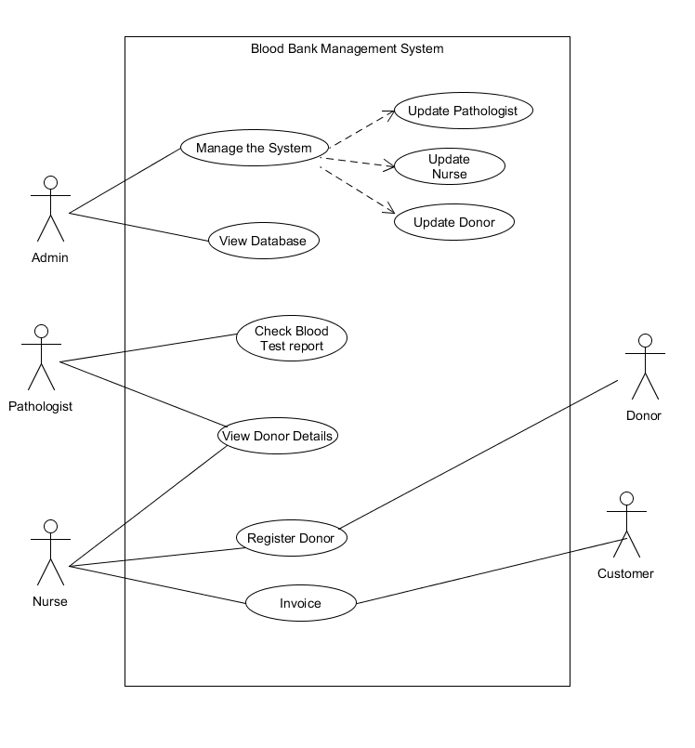

**4.1.2 Nurse Activity:**   
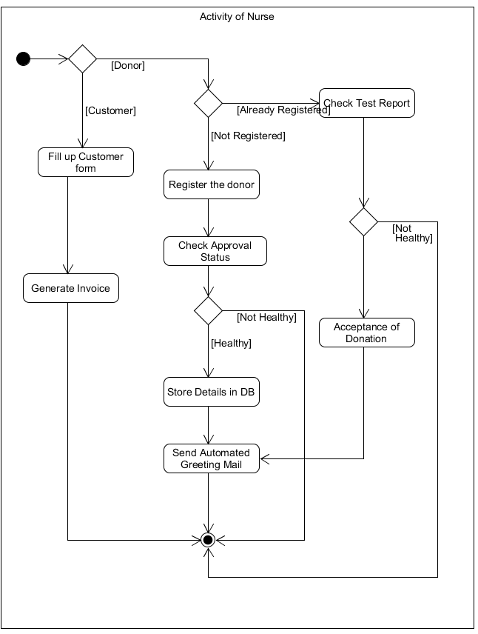

The functionality of a nurse is as follows:

* Nurse can add new donor.
* Nurse can check the approval status given by a pathologist.

**4.1.3 Activity of Admin:**

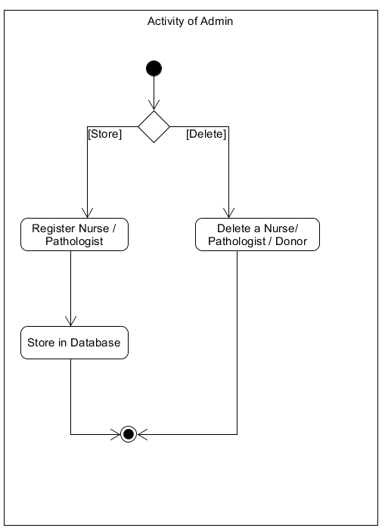

The functionality of a admin is as follows:

* Admin can add new Nurse and Pathologist.
* Admin can delete a nurse, pathologist and donor.

**4.1.4 Pathologist Activity**

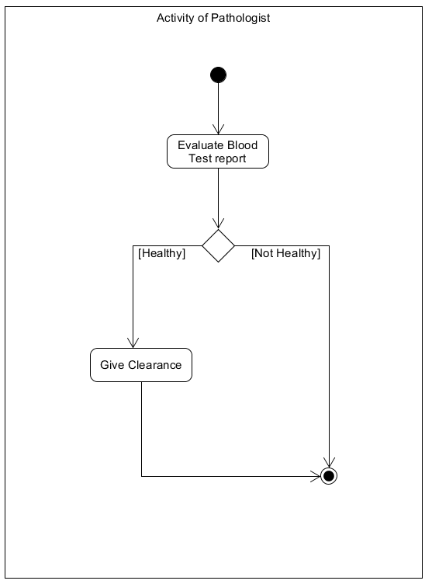

The functionality of a pathologist is as follows:

* A pathologist can approve / deny a donor donation request.

**4.2 Entity Relationship Diagram**

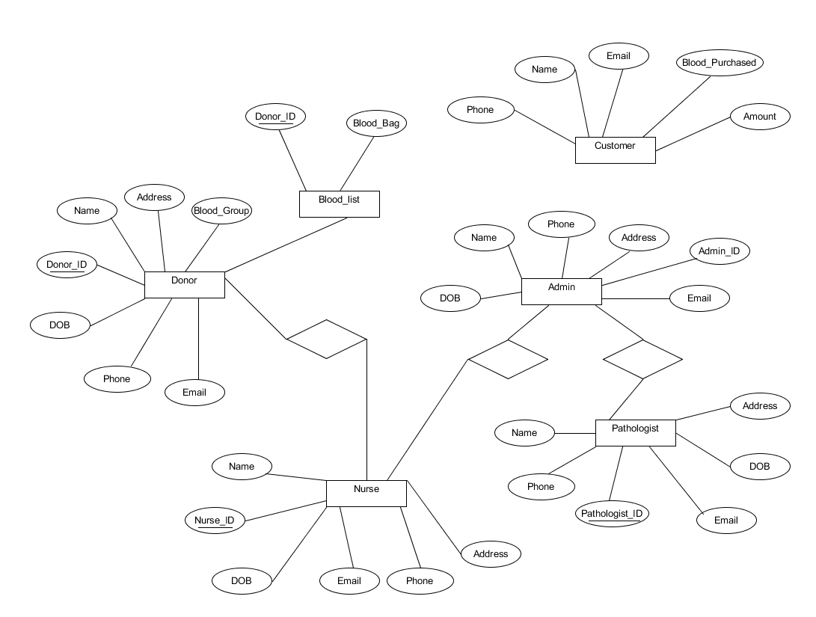

**4.3 Data Dictionary**

|  |  |  |  |  |
| --- | --- | --- | --- | --- |
| **Entity** | **Attribute** | **Size** | **Validation** | **Key** |
| **Entity** | **Attribute** | **Size** | **Validation** | **Key** |
| Admin | Admin_ID | Number(2) | 01-99 | Primary |
| Admin | Name | Varchar(30) |  |  |
| Admin | Gender | Varchar(20) |  |  |
| Admin | DOB | Varchar(20) |  |  |
| Admin | Phone | Number(11) |  |  |
| Admin | Email | Varchar(20) |  |  |
|  |  |  |  |  |
| Nurse | Nurse_ID | Number(3) | 101-999 | Primary |
| Nurse | Name | Varchar(30) |  |  |
| Nurse | Gender | Varchar(30) |  |  |
| Nurse | DOB | Varchar(30) |  |  |
| Nurse | Phone | Number(11) |  |  |
| Nurse | Email | Varchar(20) |  |  |
|  |  |  |  |  |
| Pathologist | Pathologist_ID | Number(4) | 1001-9999 | Primary |
| Pathologist | Name | Varchar(30) |  |  |
| Pathologist | Gender | Varchar(30) |  |  |
| Pathologist | DOB | Varchar(30) |  |  |
| Pathologist | Phone | Number(11) |  |  |
| Pathologist | Email | Varchar(20) |  |  |
|  |  |  |  |  |
| Donor | Donor_ID | Number(5) | 10001-99999 | Primary |
| Donor | Name | Varchar(30) |  |  |
| Donor | Gender | Varchar(30) |  |  |
| Donor | DOB | Varchar(30) |  |  |
| Donor | Phone | Number(11) |  |  |
| Donor | Email | Varchar(30) |  |  |

**4.4 Schema Diagram  
 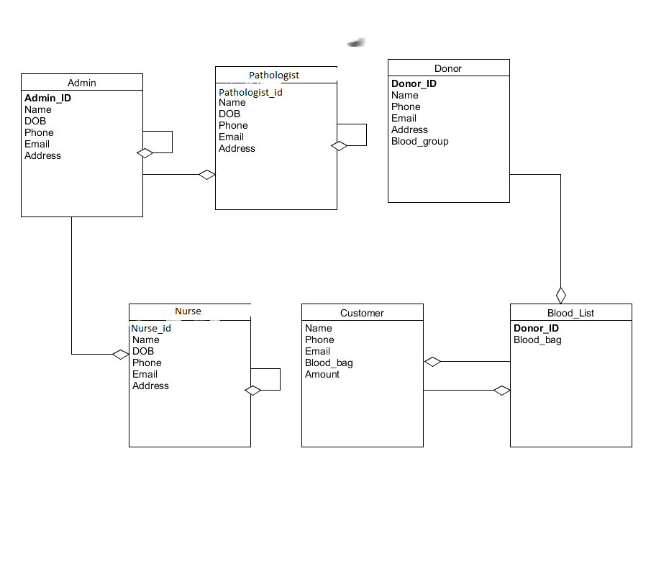**

Chapter-5: Software Project Management Plan

**5.1 Overview**

**5.1.1 Purpose, Objectives and Project Scope**

The main objective of this document is to illustrate the requirements of the project **Blood Bank Management System.** The document gives the detailed description of the both functional and non-functional requirements for this system. The document is developed after a number of studying the requirement specifications paper of the given Project. The final product of the team will be meeting the requirements of this document.

**5.1.2 Project Scope**

* Store all the details information of donors
* Making sure that all the users can do their task perfectly
* Making blood bank management more efficient
* Easy to find donor details for future references

**5.1.3 Assumptions and Constraints**

The assumptions during the projects are-

* The development team has not quite enough experience as a whole to complete the project.

The constraints during the projects are-

* Additional resources (people or money) are not available for the project.

**5.2 Project Organization**

Project organization depends on three major Structures

**5.2.1 External Interfaces**

The **Blood Bank Management System** customer relationship will be responsible for formal interaction between the developer’s team and the customer contact. Necessary interaction will be done through anyone on the team, but all discussions with the customer will be documented clearly for record. All customer requests for services or configuration item changes will be in writing and approved by the project’s Configuration Control Board (CCB), which consists of all team members.

**5.2.2 Internal Structure**

There are three developers for this project. All members have specified areas of responsibility and everybody contributes equally to the project. Because there are only three members on the team, each member holds more than one role. The team members will change roles throughout the life of the project, and each member will continue to have more than one role.

**5.2.3 Roles and Responsibilities**

The software developers are responsible for all documentation to be developed and also for all work to be done.

**5.3 Managerial Process Plans**

**5.3.1 Project Start-up Plan**

This section describes the materials and resources required to start the project. Because most of this information was pre-defined for the team, this section will not describe the rationale for many of these choices.

**5.3.2 Estimation Plan**

As previously stated in that, the total development time is estimated to be 6 days and the total internal cost to be BDT. These figures were obtained by expert judgment by analogy, that is, by comparison with similar projects.

**5.3.3 Staffing Plan**

Each team member will be available for 8 hours per day as the project purpose. This time includes the team and supervisor meetings, document preparation and inspection, and tool development.

**5.3.4 Resource Acquisition Plan**

* All resources for the project will be available at the start of the project and will not change substantially over time. Below are the planned changes: The technical writer will change after completing a documentation
* The team member’s roles will change according to project needs

**5.3.5 Project Staff Training Plan**

No additional staff training is needed for this project**.**

**5.4 Control Plan**

**5.4.1 Requirements Control Plan**

When changes are to be made in the requirements after the Software Requirement Specification has been released, the changes shall be brought to the attention of the developers and discussed. Any changes that are to be made will be with the prior approval of the supervisor and only if feasible and permissible within the constraints of the project and resources in terms of knowledge and skill of the developers required. Once the changes have been made to the Software Requirement Specification document, an updated version of the Software Requirement Specification will be released.

**5.4.2 Schedule Control Plan**

If the work scheduled in section 1.1.4 is gets behind, the developer will be ready to spend extra time on the project in between and after the schedules to make up for the lost time and deliver the final project on time.

**5.4.3 Budget Control Plan**

Average monthly income will be determined by totaling all earnings for the year and dividing by 12. Average monthly spending will be generated by tracking all expenditures. "The difference between "Budget" and "Current Spending" will be the savings. If expenditure exceeds the income than steps may be follow to cut back on expenditures, depending on the specific savings goals. Expenses are monitored by the project manager, and reported and accessed via the Weekly Status Report.

**5.4.4 Quality Control Plan**

Any major changes that affect the milestones or the budget will have to be approved by all and documented. All will be responsible for ensuring that the project will be completed on time and within budget. This will be accomplished through daily meetings of the team members with the supervisor. At each meeting, developer team will present the day’s progress and problems. Al will determine whether they are progressing as expected and whether they are following the specification document and the project management plan. Any major problems faced by the team members will immediately be reported to all.

**5.4.5 Reporting Plan**

The updated Software Project Management Plan will be circulated as mentioned in schedule of section 1.1.4. Each of preliminary versions of all the documents and updates and status reports will be sent and discussed with the advisor and upon approval the approved document will be circulated to the other members of the team. The report on the status of the project will be sent to the members of the team.

**5.4.6 Metrics Collection Plan**

As the system based on object oriented so the metrics focus on measurement that can be applied to the class and the design characteristics—localization, encapsulation, information hiding, inheritance, and object abstraction techniques—that make the class unique.

**5.5 Closeout Plan**

At the end of the project, the following actions will occur:

* The developer team will make a hard copy file of all documents, source code, plans, etc. generated by the team.
* The developer team will also copy of all material in electronic format on a DVD-ROM

**5.6 Other plans**

**5.6.1 Technical process plans**

The Software Project Management Plan will specify the development process model, technical models, tools and techniques that will be used to develop the work products, project infrastructure and product acceptance plan.

**5.6.2 Process Model**

The XP (extreme Programming) agile process model will be follow during the project implementation.

**5.6.3 Methods, Tools and Techniques**

The project, **Blood Bank Management System**, adapts the system on Personal Computer using Microsoft Visual studio 2015 and MySQL for database management system. Additional tools that will be used are Adobe Photoshop etc.

**5.6.4 Infrastructure Plan**

The hardware resources are three Intel Core i5 Personal Computers running Windows 10 operating system. The project using software resources are like Microsoft Visual Studio 2015 and Github.

**5.6.5 Product Acceptance Plan**

Every milestone of the project will be accepted formally by the project manager by signing appropriate acceptance documentation. At the end of every phase the project manager will perform an acceptance test. This may result in additional requests for change and improvements. The project manager will test the final product/application for acceptance.

**5.6.6 Supporting Process Plans**

The Software Project Management Plan will include the plans for the supporting processes that are part of the software project. These plans include: configuration management plan, verification and validation, software documentation, quality assurance, reviews and audits, problem resolution and subcontractor management.

**5.6.7 Configuration Management Plan**

All the project deliverables are to be considered as configuration items. The configuration item as well as its file would be named after the document like SOW, SRS and followed by the version number. For example, all the preliminary versions that are submitted to the project manager for review would be named with the abbreviation followed by 0.1, 0.2. After the project manager approves the basic SPMP, this baseline document will be version 1.0 and is distributed to the project members. Informal updates with the project manager will be numbered with 1.1, 1.2, etc. and the next full distribution to the committee would be version 2.0, etc.

**5.6.8 Verification and Validation Plan**

The Software Project Management Plan for this project shall contain the verification and validation plan for the software project and it shall include tools, techniques and responsibilities for the verification and validation work activities. The verification and validation plan will be part of a separate document and will be maintained accordingly.

**5.6.9 Documentation Plan**

The IEEE standards would be followed for all documentation purposes. All the documents would be discussed and reviewed with project manager before their baseline versions are issued and distributed to the members of the committee on the due dates.

**5.6.10 Quality Assurance Plan**

The quality of our project will be maintained and checked by the project manager. He will assure that this project is maintaining the quality.

**5.6.11 Reviews and Audits Plan**

Review and Audits would be addressed as a part of the Software Quality Assurance and Verification & Validation Plan that would be developed following recommended departmental standards.

**5.6.12 Problem Resolution Plan**

All problems would be resolved informally the developer and the project manager. That is, there is no specific plan. But, The Software Project Management Plan will be updated accordingly should the need for such a plan arises.

**5.6.13 Subcontractor Management Plans**

The project does not have any plan for managing subcontractors that may contribute work products to the software project.

**5.6.14 Process Improvement Plan**

After the development, the project will be regularly checked by the project manager and he will suggest the developers if any kind of improvement is needed.

Chapter-6: User Interface

User Interface (UI) Design focuses on anticipating what users might need to do and ensuring that the interface has elements that are easy to access, understand, and use to facilitate those actions. UI brings together concepts from interaction design, visual design, and information architecture.

**6.1 Login panel**

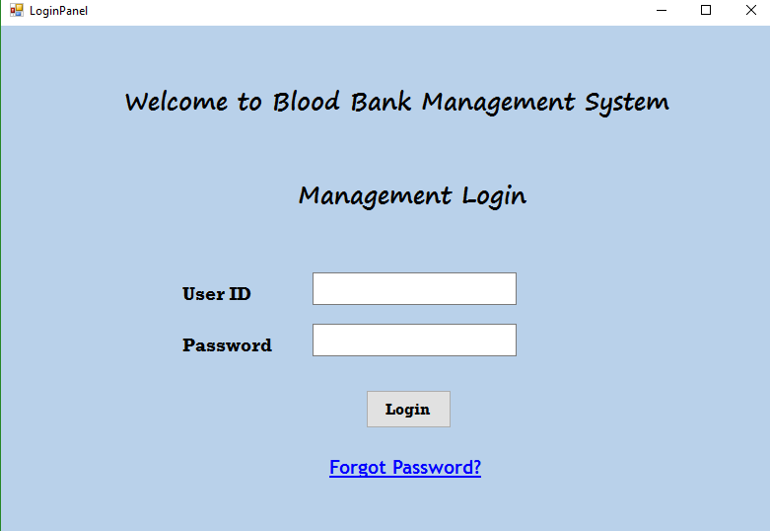

**6.2 Donor Registration Panel**

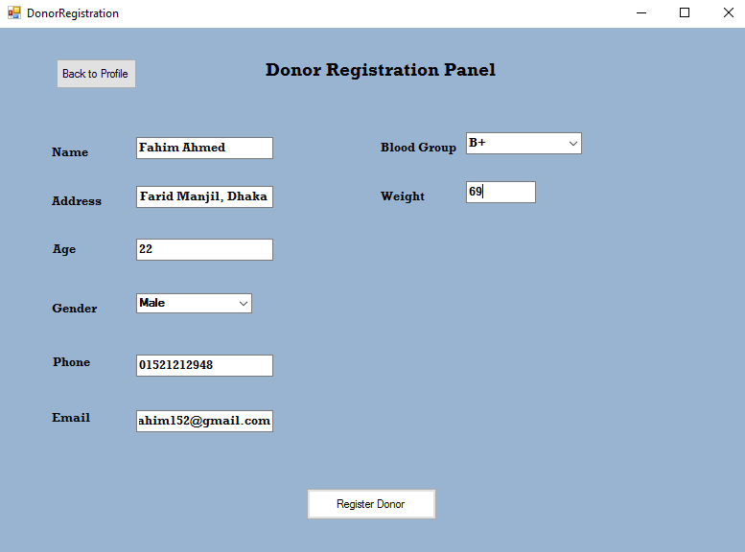

**6.3 Admin Panel**

**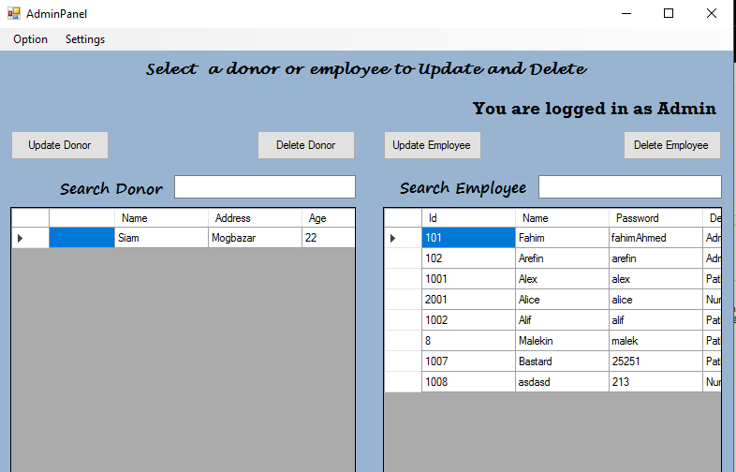  
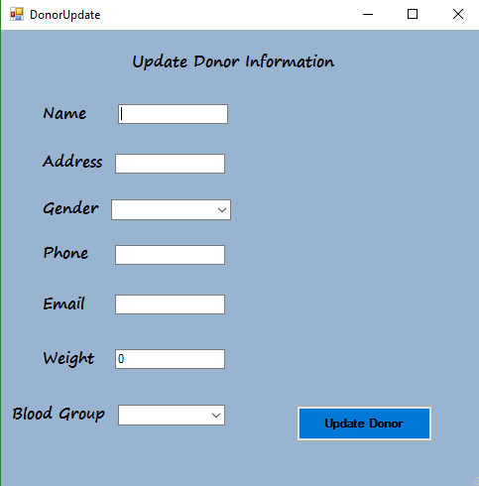**

**6.4 Pathologist Panel**

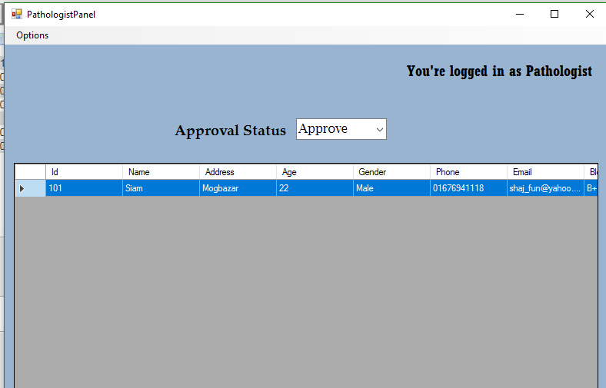

**6.5 Nurse Panel  
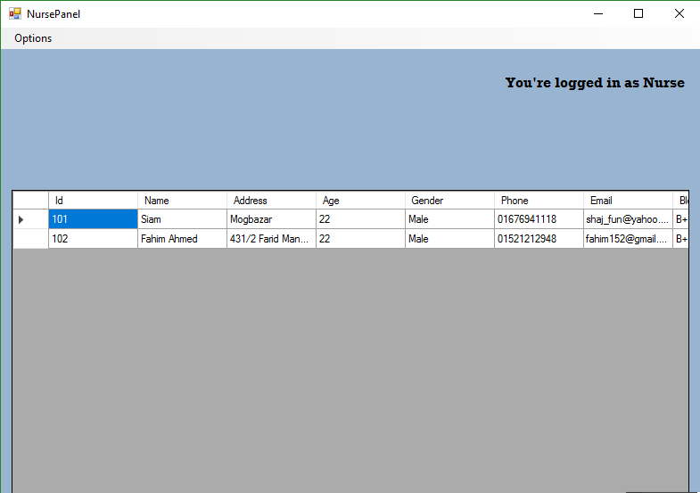**

Chapter-7: Conclusion

**7.1 Future Aspect:**

* Add Bar Chart and Pie chart
* Add more graphical representation
* Upgraded it to web based
* More User Friendly

**7.2 Conclusion:**

It has been a matter of immense pleasure, honor and challenge to have this opportunity to take up this project and complete it successfully.

While developing this project we have learnt a lot about **Blood Bank Management System**, we have also learnt how to make it user friendly (easy to use and handle) by hiding the complicated parts of it from the users.

During this development process we studied carefully and understood the criteria for making software more demanding we also realized the importance of maintaining a minimal margin for error.

**Bibliography**

* <http://www.umlet.com/>
* OMG “Unified Modeling Language Specification”, Superstructure Version 2.5, October 2012
* https://msdn.microsoft.com/en-us/library/aa288436(v=vs.71).aspx